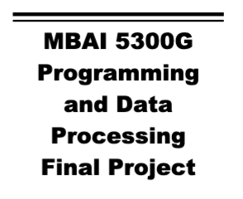
Litmus: A Multi-Strategy Algorithmic Trading Analytics Platform Using Python, Backtrader, and Streamlit
Group 1 Members:
Olusola Odunlami
Kayode Olusanya
Mawufemor Damalie
Mofoluwasho Kayode
Professor: Amin Ibrahim
Institute: Ontario Tech University
Date: November 21, 2025

Abstract
This project presents the design and development of Litmus, an interactive algorithmic trading analytics platform built in Python using Backtrader, Streamlit, Plotly, and market data from Yahoo Finance. The goal of the platform is to help users test and analyze multiple rule-based trading strategies on historical stock data, understand how much money each strategy would have made or lost over time, and compare risk-adjusted performance across assets.
Litmus supports strategies such as Simple Moving Average (SMA) Crossover, Relative Strength Index (RSI), Bollinger Bands, MACD, Momentum, and Buy-and-Hold. It offers four main capabilities: single asset backtesting, a “Strategy Lab” for parameter tuning, multi-asset comparison, and advanced analytics including Sharpe Ratio, volatility, success rate, profit factor, cumulative profit/loss, and maximum drawdown. The app visualizes both price movement and the equity curve, which shows how a portfolio’s value changes over time during the backtest.
Results from experiments on large-cap technology stocks suggest that no single strategy consistently dominates. Trend-following strategies perform strongly in trending markets but can suffer during choppy conditions, while mean-reversion strategies like RSI behave differently depending on volatility. The platform demonstrates how combining visualization, statistics, and backtesting can improve understanding of strategy behavior before risking capital in live markets. Limitations include data quality assumptions, simplified execution assumptions, and no transaction costs. Future work may extend Litmus with machine learning–based signals and portfolio optimization.
Keywords: Algorithmic trading, backtesting, equity curve, technical analysis, Sharpe ratio, portfolio analytics.

I. Introduction
The Litmus Quant Dashboard project offers a powerful and user-friendly platform for traders and analysts. It uses a solid Python stack, including Streamlit for the interactive interface, yfinance for data collection, Backtrader as the simulation engine, and Plotly for visualization. The main purpose of this application is to conduct quick and thorough backtesting of trading strategies against historical market data. Users can select securities, define date ranges, choose from six fully implemented strategies, and adjust their parameters. Importantly, the platform goes beyond simple asset analysis to include Portfolio-Level Analytics, treating all tested assets as a single combined entity. The result is a detailed dashboard that features key risk and return metrics, an interactive candlestick chart displaying trades, and essential charts such as the Equity Curve and Cumulative Profit/Loss & Drawdown chart. These tools are all designed to help evaluate a strategy’s performance and stability.
The goal of this project is to design and implement Litmus, a multi-strategy algorithmic trading analytics platform that allows users to:
- Backtest multiple trading strategies on any stock ticker using historical market data.
- See how much money each strategy makes, using metrics such as return percentage and final portfolio value.
- Visualize both price and the equity curve (the evolution of portfolio value over time).
- Analyze risk and performance with metrics such as Sharpe Ratio, volatility, success rate, profit factor, and maximum drawdown.
- Compare the same strategy across different assets in a multi-asset view.
- Use an Advanced Analytics mode to evaluate strategies in a more “institutional” way.
The scope of Litmus is focused on technical-analysis-driven strategies (such as moving averages and oscillators), traditional risk-adjusted metrics from modern portfolio theory (Markowitz, 1952; Sharpe, 1966), and practical visualization techniques. The platform is not meant to be a full trading system but rather a sandbox for learning, experimentation, and evaluation.

II. Literature Review

2.1 Technical Analysis and Trading Rules
Technical analysis has been used for decades to analyze price and volume data to identify trading opportunities. Common tools include moving averages, oscillators, and volatility bands (Murphy, 1999). Strategies such as:
- SMA Crossover – uses two moving averages (fast and slow) and generates signals when they cross.
- RSI (Relative Strength Index) – measures momentum and identifies overbought/oversold conditions.
- MACD (Moving Average Convergence Divergence) – captures trend and momentum through EMAs and a signal line.
- Bollinger Bands – create dynamic price bands around a moving average based on volatility.
have been widely studied in both academic and practitioner literature. These indicators tend to perform differently depending on whether the market is trending, ranging, or highly volatile.

2.2 Risk, Return, and Portfolio Thinking
Harry Markowitz’s (1952) Modern Portfolio Theory (MPT) introduced the idea that investors should evaluate portfolios not only on expected returns but also on risk, often measured by variance or standard deviation. This led to the concept of the efficient frontier and trade-offs between risk and return.
The Sharpe Ratio, introduced by Sharpe (1966), became a standard metric for comparing portfolios and strategies by measuring return per unit of risk. In practice, traders often examine:
- Return %
- Volatility (annualized standard deviation of returns)
- Maximum drawdown (largest peak-to-trough decline)
- Risk-adjusted performance (e.g., Sharpe Ratio)
These metrics are central to Litmus’ Advanced Analytics mode.

2.3 Backtesting and Overfitting
Backtesting is the process of applying a strategy to historical data to see how it would have performed. While essential, backtesting can be misleading if not done carefully. Bailey, Borwein, López de Prado, and Zhu (2014) warn about backtest overfitting, where strategies are tuned so much to past data that they perform poorly in the future. This highlights the importance of transparency, multiple metrics, and not relying on a single backtest result.

2.4 Tools and Libraries
Python has become an industry standard for quantitative finance because of its extensive ecosystem. In this project, several key libraries and tools are used:
- Backtrader – a backtesting framework for running trading strategies on historical data (Backtrader, n.d.).
- yfinance – a Python library that retrieves historical market data from Yahoo Finance (Yahoo Finance, n.d.).
- Streamlit – a framework for building data apps interactively in Python (Streamlit, n.d.).
- Plotly – a library for building interactive charts in the browser, including candlestick and line charts (Plotly, n.d.).

2.5 Gap in Practice
While many tutorials and tools exist, there is still a gap between:
- Academic finance theory,
- Indicator explanations, and
- A unified, interactive tool where users can test multiple strategies, compare them across assets, and see both price and equity curves with detailed metrics.
Litmus aims to bridge that gap in a practical, hands-on way.

III. Methodology

3.1 Overall Design
Litmus was designed as a modular, interactive dashboard with multiple modes:
- Run Backtest – run several strategies on a single stock.
- Strategy Lab – tune parameters for one strategy at a time and visualize entries/exits.
- Multi-Asset Comparison – apply one strategy to multiple tickers.
- Advanced Analytics – compute and visualize risk-adjusted metrics and portfolio-level performance.
Each mode is built on top of the same core components: data loading, strategy execution through Backtrader, and visualization via Plotly within a Streamlit app.

3.2 Data Source and Collection
Historical market data is retrieved using the yfinance library, which connects to Yahoo Finance (Yahoo Finance, n.d.). For each backtest, users specify:
- A ticker symbol (e.g., AAPL, MSFT, TSLA).
- A start date and end date.
- The frequency (daily price data by default).
The following fields are loaded:
- Open, High, Low, Close, Adjusted Close
- Volume
The data is converted into a Pandas DataFrame, which is then cleaned and standardized.

3.3 Data Cleaning and Preparation
A helper function clean_data () performs several steps:
- If columns are a MultiIndex (which can happen when downloading multiple symbols), they are flattened.
- Column names are converted to lowercase.
- Missing values are dropped to avoid issues in indicators.
- Volume is converted to a float when necessary.
- In Advanced Analytics, daily returns are computed as:
data["returns"] = data["close"].pct_change()
These returns are used to compute Sharpe Ratio, volatility, equity curves, and drawdowns.

3.4 Strategy Implementation in Backtrader
Each trading strategy is implemented as a class that inherits from a shared Base Strategy. This base class:
- Initializes lists to store signals and trades.
- Provides a log_signal() method to record buy/sell actions along with date and price.
- Overrides notify_trade() to record profit or loss when a trade closes.
Example strategies include:
- SMA Crossover – uses two simple moving averages:
  - Buys when fast SMA crosses above slow SMA.
  - Sells when fast SMA crosses below slow SMA.
- RSI Strategy – uses the Relative Strength Index:
  - Buys when RSI falls below a lower threshold (e.g., 30).
  - Sells when RSI rises above an upper threshold (e.g., 70).
- MACD Strategy – uses MACD and signal line crossover.
- Bollinger Bands – buys when price touches the lower band and sells when it touches the upper band.
- Momentum – buys when the current price is higher than the price from “n” days ago and sells when the opposite is true.
- Buy & Hold – buys once and holds until the end of the backtest.
Using Backtrader ensures that order handling, position tracking, and cash/equity updates are handled in a realistic and consistent way (Backtrader, n.d.).

3.5 Backtesting Engine Logic
The core function run_bt(data, strategy_class, cash, **kwargs):
- Cleans the input price data.
- Initializes a Backtrader “Cerebro” engine.
- Sets the starting capital (e.g., 10,000).
- Wraps the DataFrame in a PandasData feed.
- Adds the selected strategy class and passes any parameters.
- Runs the backtest.
- Extracts:
- Final portfolio value (end).
- Total return percentage (ret).
- List of trade profits to compute win rate and drawdown.
- Logged signals for later plotting.
This function is reused across all modes to ensure consistent behavior.

3.6 Visualization: Price and Equity Curves
Plotly is used to build interactive charts:
- Candlestick chart for price:
  - Open, high, low, and close are shown with green and red candles to represent up and down days.
- Equity curve chart:
  - Computes how the portfolio value changes over time starting from a chosen initial cash value (e.g., 10,000).
  - The equity curve is calculated via cumulative returns:
- data["equity_curve"] = (1 + data["returns"]).cumprod() * cash
- data["profit_loss"] = data["equity_curve"] - cash
- Drawdown chart:
  - Uses rolling maximum of equity to compute percentage drawdown.
These visuals are displayed in Streamlit, allowing zooming, hovering, and comparison.

IV. Data Analysis
This section describes how each mode of the app processes data and what insights it provides.

4.1 Run Backtest Mode
In Run Backtest, the user selects a single ticker, a date range, starting capital, and one or more strategies. When the backtest is run, Litmus:
- Downloads and cleans the historical data.
- Runs each strategy separately on the same dataset.
- Produces a results table with columns such as:
  - Return %
  - Final Value
  - Win Rate %
  - Max Drawdown %
- Shows a candlestick price chart so the user can see how the stock moved over time.
This mode answers a very direct question: “If I traded this stock with these strategies over this period, which one would have made me more money, and with how much risk?”
For example, applying SMA Crossover, RSI, and Buy & Hold on AAPL from 2020 to 2024 may show that Buy & Hold performed best in a strong bull run, while SMA Crossover moderated drawdowns during choppier periods. This supports the idea that strategy performance is closely tied to market regime (Hull, 2020; Murphy, 1999).

4.2 Strategy Lab Mode
The Strategy Lab is designed for tuning and exploration. In this mode, users:
- Select a single strategy (e.g., SMA Crossover or RSI).
- Adjust key parameters with sliders:
  - SMA fast and slow lengths.
  - RSI period, buy threshold, and sell threshold.
- Run the backtest with the chosen configuration.
The output includes:
- A candlestick chart of the price.
- Strategy buy and sell markers on the chart (for example, triangles where trades are opened and closed).
- Summary metrics for the strategy, including return, final value, and win rate.
- (With the enhancements discussed) an equity curve beneath the price chart.

4.3 Multi-Asset Comparison Mode
In Multi-Asset Comparison, the user:
- Enters several tickers (e.g., AAPL, MSFT, TSLA, NVDA).
- Selects one strategy (for example, RSI or Momentum).
- Runs the strategy on all selected symbols using the same capital and time period.
The app then:
- Runs a separate backtest for each asset.
- Builds a comparison table summarizing:
  - Return %
  - Final Value
  - Win Rate %
  - Max Drawdown %
- Plots a multi-line chart of closing prices to show how each asset moved over time.
This mode helps answer questions like:
- “Does this strategy work better on technology stocks than on car manufacturers?”
- “Which asset is most suitable for my chosen strategy?”
For example, a momentum strategy may work very well on a stock like NVDA, which has experienced strong trends, but may struggle on a more range-bound stock. This aligns with the idea that strategy design and asset selection are tightly linked (Markowitz, 1952; Hull, 2020).

4.4 Advanced Analytics Mode
The Advanced Analytics mode provides a more institutional-quality analysis. For each symbol, Litmus calculates:
- Return % – overall performance.
- Volatility % – annualized standard deviation of returns.
- Sharpe Ratio – risk-adjusted return (Sharpe, 1966).
- Win Rate % – percentage of winning trades.
- Success Rate % – similar to win rate, focusing on trade-level outcomes.
- Profit Factor – total profit from winning trades divided by total loss from losing trades.
- Cumulative P/L ($) – total dollar profit or loss from the strategy.
- Max Drawdown % – deepest portfolio drops from peak to trough.
In addition, the mode:
- Plots equity curves for each symbol.
- Creates a portfolio by averaging equity across symbols and computes:
  - Portfolio-level Sharpe.
  - Portfolio return.
  - Portfolio drawdown.
- Visualizes Cumulative Profit/Loss and Drawdown over time for the most recent symbol.
This mode not only shows how much money a strategy would make but also how stable or fragile that performance is.

V. Discussion

5.1 Linking Results to Theory
The behavior observed in Litmus is consistent with financial theory and evidence from previous research:
- Trend-following strategies like SMA Crossover and Momentum tend to do well in trending markets but can whipsaw in sideways markets (Murphy, 1999; Hull, 2020).
- RSI and Bollinger Bands, which rely more on mean-reversion, can work well in range-bound conditions but may struggle when strong trends dominate.
- High Sharpe Ratios are seen when returns are smooth and drawdowns are limited, supporting Sharpe’s (1966) risk-adjusted performance framework.
- Some backtests that look “too good” signal a risk of overfitting, which aligns with the warnings from Bailey et al. (2014).

5.2 Practical Implications
From a practical standpoint, Litmus demonstrates:
- The importance of equity curves, not just final return numbers. Two strategies can have similar final returns but very different paths.
- Why traders often care deeply about drawdowns; a strategy that loses 50–60% at some point may be psychologically intolerable, even if it recovers later.
- How multi-asset analysis helps identify whether a strategy is robust across several securities or overly tailored to one ticker.
- The value of a visual and interactive environment where students and practitioners can experiment safely.

5.3 Limitations
There are several limitations to the current version of Litmus:
- Data quality and survivorship bias – Yahoo Finance data is convenient but not 100% free of issues. Corporate actions, delisting’s, and data gaps can affect results (Yahoo Finance, n.d.).
- No transaction costs or slippage – Real-world trading involves commissions, bid–ask spreads, and slippage. These are not yet modeled.
- Backtest overfitting – Users can tune parameters until results look “perfect” on past data, which does not guarantee future performance (Bailey et al., 2014).
- Strategy simplicity – The current strategies are mostly single-indicator rules. More complex, multi-factor approaches could behave differently.

5.4 Future Improvements
Potential future enhancements include:
- Machine learning–based models that learn patterns from data rather than relying solely on predefined indicators.
- Reinforcement learning agents that learn trading policies through interaction with logged market data.
- Portfolio optimization modules grounded in Markowitz (1952), allowing optimal allocation across strategies or assets.
- Transaction cost modeling and more realistic execution assumptions.
- Deployment as a web application where multiple users can log in, save configurations, and share results.

VI. Conclusion
This project set out to build an interactive, educational, and practical platform for algorithmic trading analytics. Litmus successfully integrates:
- Historical data retrieval via yfinance and Yahoo Finance.
- Strategy execution and portfolio tracking via Backtrader.
- A user interface via Streamlit.
- Visual analytics through Plotly, including candlestick price charts and equity curves.
The platform demonstrates that:
- Different strategies behave very differently under various market conditions.
- Risk-adjusted metrics such as Sharpe Ratio, volatility, and drawdown are essential to understanding strategy quality.
- Visualizing both price and the equity curve provides a much clearer picture of how a strategy behaves over time than a single final number.
Litmus is not a trading recommendation engine, but rather a sandbox where strategies can be explored, understood, and compared before being deployed in live markets. For students and practitioners, it acts as a bridge between theoretical concepts and real-world data.
As financial markets continue to evolve and algorithmic tools become more accessible, platforms like Litmus can help demystify quantitative strategies, promote disciplined analysis, and encourage experimentation grounded in data rather than emotion.

References
Bailey, D. H., Borwein, J., López de Prado, M., & Zhu, Q. J. (2014). The probability of backtest overfitting. Journal of Financial Data Science.
Backtrader. (n.d.). Backtesting trading strategies in Python. Retrieved from https://www.backtrader.com
Hull, J. C. (2020). Options, futures, and other derivatives (11th ed.). Pearson.
Markowitz, H. (1952). Portfolio selection. The Journal of Finance, 7(1), 77–91.
Murphy, J. J. (1999). Technical analysis of the financial markets. New York Institute of Finance.
Plotly. (n.d.). Interactive graphing library for Python. Retrieved from https://plotly.com
Sharpe, W. F. (1966). Mutual fund performance. The Journal of Business, 39(1), 119–138.
Streamlit. (n.d.). The fastest way to build data apps. Retrieved from https://streamlit.io
Yahoo Finance. (n.d.). Historical market data. Retrieved from https://finance.yahoo.com

Appendices
Appendix A – Run Backtest Screen
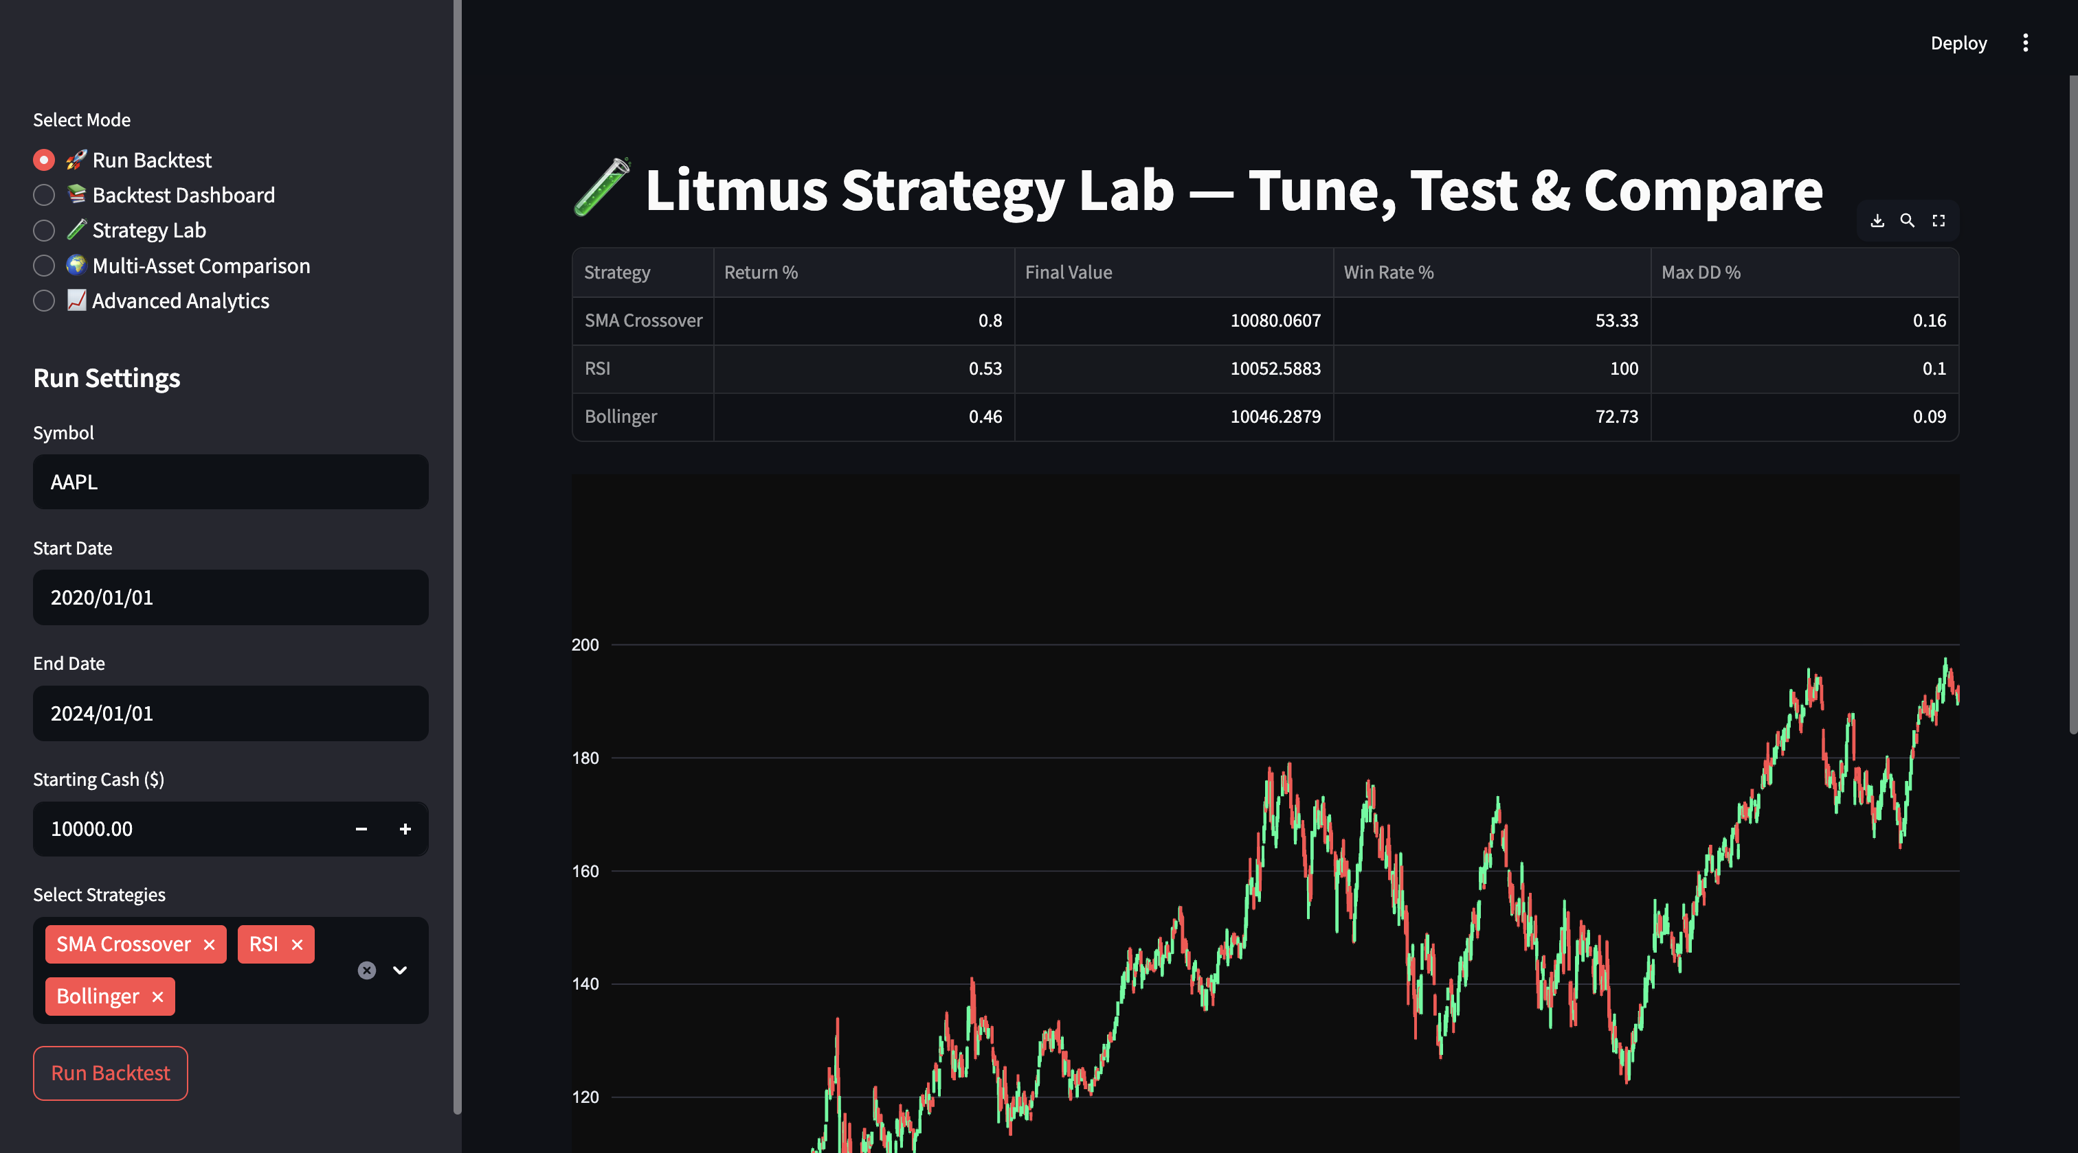

Appendix B – Strategy Lab Screen
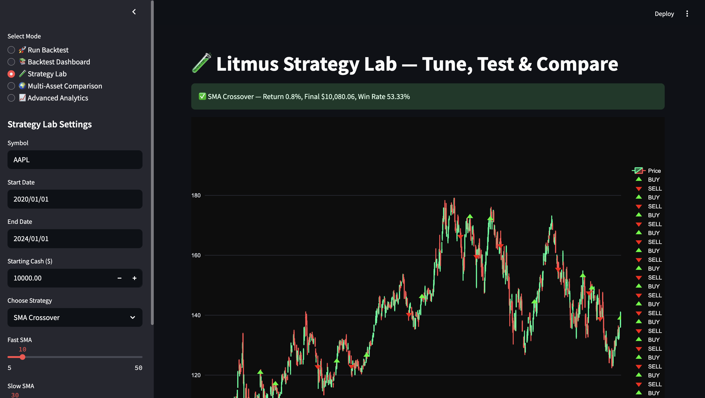

Appendix C – Multi-Asset Comparison Screen

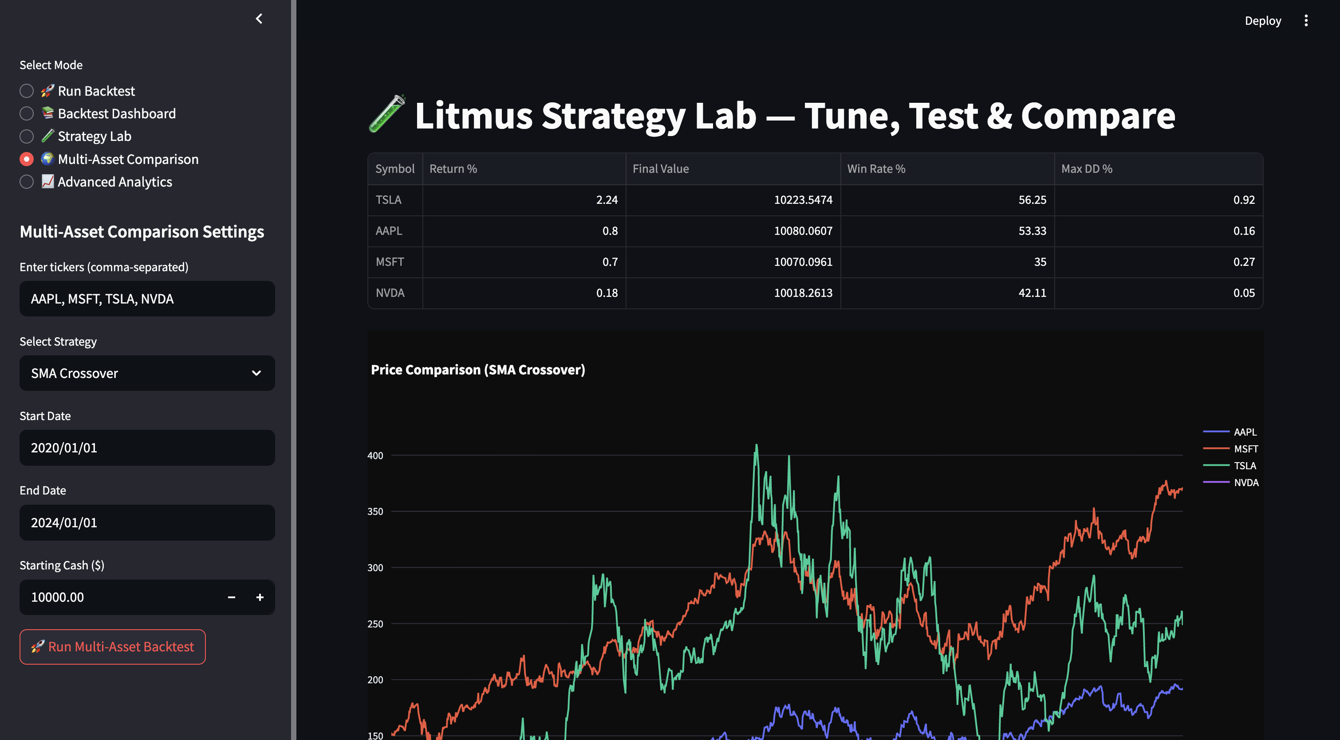

Appendix D – Advanced Analytics Screen
